imgDesk User Manual

*As of Tuesday, the 13th of August 2013.*

Welcome to the imgDesk user manual. This user manual gives a brief overview of the web application and includes some FAQ’s, instructions and descriptions. It is updated approximately every 10 – 15 days.

Introduction

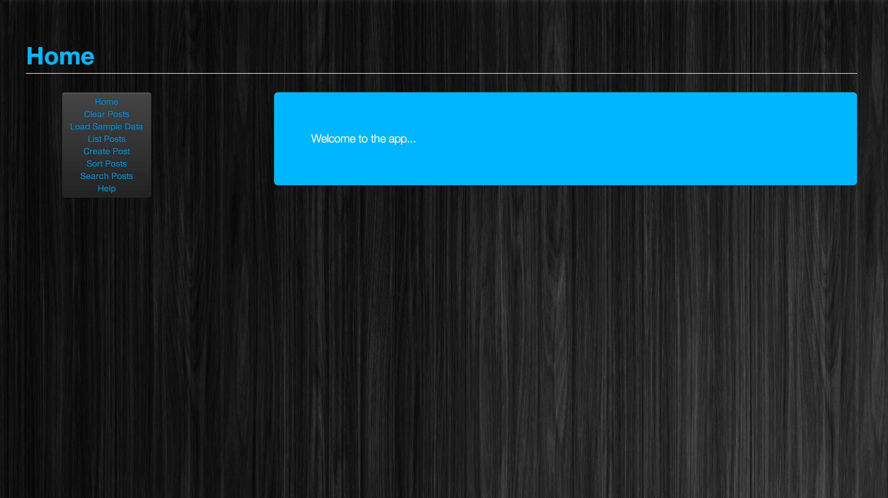

*A screenshot from the current working version of the web app.*

imgDesk is a simple, concise and elegant web application that enables users to, in the current version:

* Add posts
* Delete posts
* Modify posts
* Search posts
* Sort posts

FOR DEVELOPERS: This is achieved using “mongo”, “express” and “node js”. The Webstorm IDE was used for development of the web application. The overlying theme is created using twitter bootstrap.

Versions

imgDesk is currently still under development (currently in Beta), and thus full functionality is not yet available. However, very soon users will see the ability to search and sort posts become fully working.

Information on the project

**What can we expect in the future from imgDesk?** A fully working version (scheduled due in the next week) will include fully working sort and search functionality. The full version will also have some improvements to the “List posts” and hence “Sort posts” displays – the posts will no longer be displayed in a traditional table but will instead follow a more standard blog style post display where each post has a heading at the top (including date and author), followed by the body. Past the due date, users can expect to see more and more implementations including user membership, support for video and image uploads, and any bug fixes which need be done.

**I don’t like the current theme. How can I change it?** Currently, imgDesk uses a twitter bootstrap styled webpage with a blue and black colour scheme. In the future, when user membership becomes available, there should be implementation in the ability for a user to modify how they view the web app.

**This user manual is quite short. I don’t find it very helpful.** At the moment, the imgDesk user manual is quite small. This is due to the current overall functionality and ability of the web app. In the very next week imgDesk is going to reach its completion and become version 1.0, and along with this release the DCMS user manual will be updated to accommodate for this with the inclusion of:

* a step-by-step guide to using the web app
* a generally more user friendly, colourful user manual
* a much more descriptive overview of the web application.

As said before, users can expect to see version 1.0 and the updated user manual by the 11th of August 2013 (in one week).

Quick Help

**I have typed in a heading in the search bar and I keep getting a display telling me that there are “No posts to search”; how do I fix this?**

The idea of the application is that you create your own posts. Visit ‘create posts’ on the menu sidebar.